1.
Prove by mathematical induction.

2.
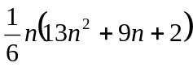

3.
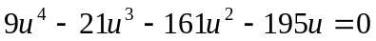

4.
(i) 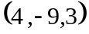
(ii) 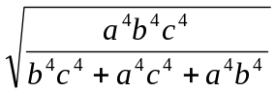

5.
(i) 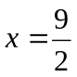 , 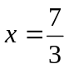 and 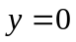
(ii) 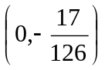, 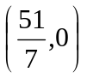
(iii) local maximum point : 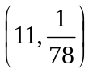 , local minimum point : 